|  |  |  |
| --- | --- | --- |
| Angular 4  Environment Setup and Startup Guide | What’s in  Complete environment setup and all required software installation with simple Skelton app structure step by step for Angular 4   |  | | --- | | **Written in**: TypeScript  **Type:** JavaScript, Single Page Application, Framework  **Platform:** Cross-platform, modern browsers only  **Developed by:** Google  Official website : [angular.io](https://angular.io/) |   Md Hidaytullah Rahmani  Angular 4 Start Guide |

Table of Contents

1 Installation and Setup 2

1.1 Required Tools and Software 2

1.1.1 Editor 2

1.1.2 Install Editor 2

1.2 Setup Node Environment (Node NPM) 8

1.2.1 Install Node and NPM 8

2 Start with Angular 4 12

2.1 First Project Setup 12

2.1.1 Basic requirement for angular 4 12

2.1.2 Angular CLI 12

3 Advance Setup 19

3.1 Change default Port 19

4 F.A.Q about angular 4 Fact 19

# Installation and Setup

## Required Tools and Software

### Editor

**Visual Studio Code** – Recommended

### Install Editor

1. Go to the official website **Visual Code Studio** - Editor

Here: <https://code.visualstudio.com/>

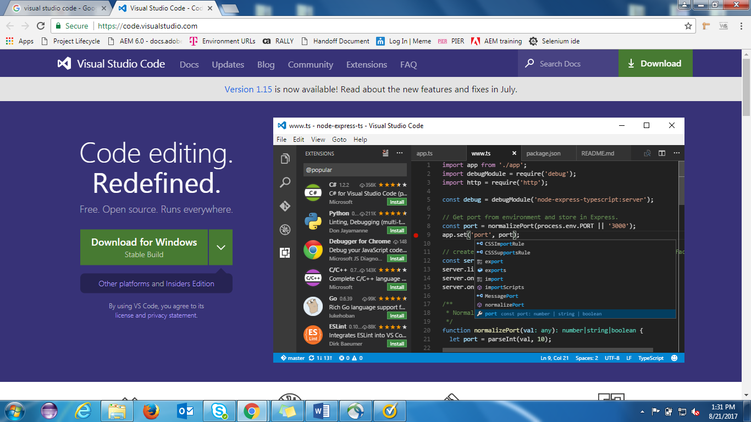

1. Download the setup according to your **OS** and bit, in my case I’ve **window 10, 64bit**
2. After download Double click on **setup** to install

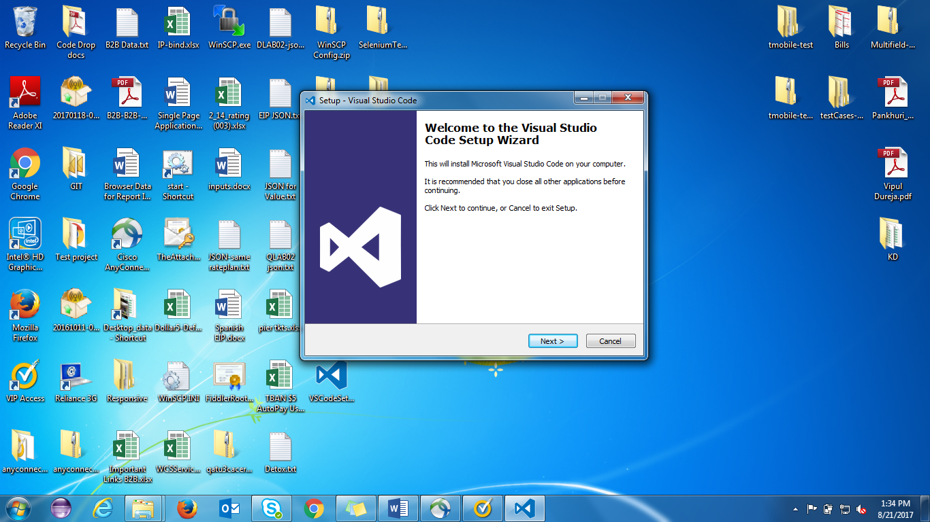

Click on **Next**

1. Click on – **I accept the agreement**

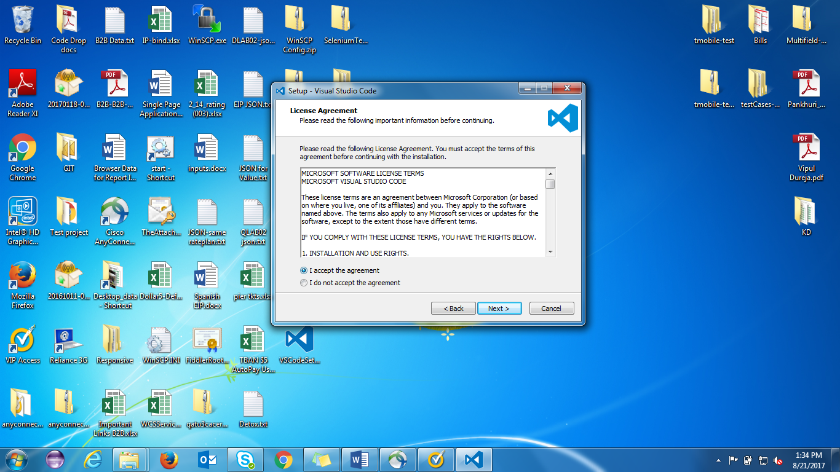

Click on **Next**

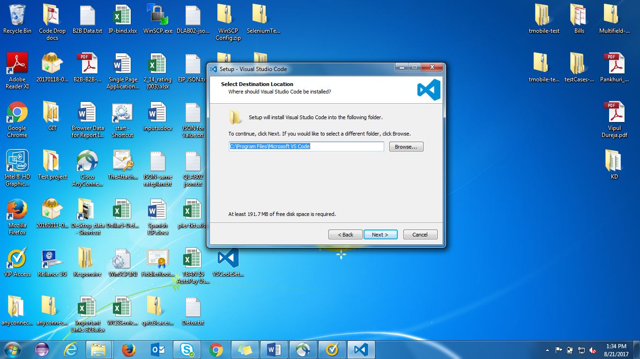

1. Choose path (or keep it same) and click **Next**

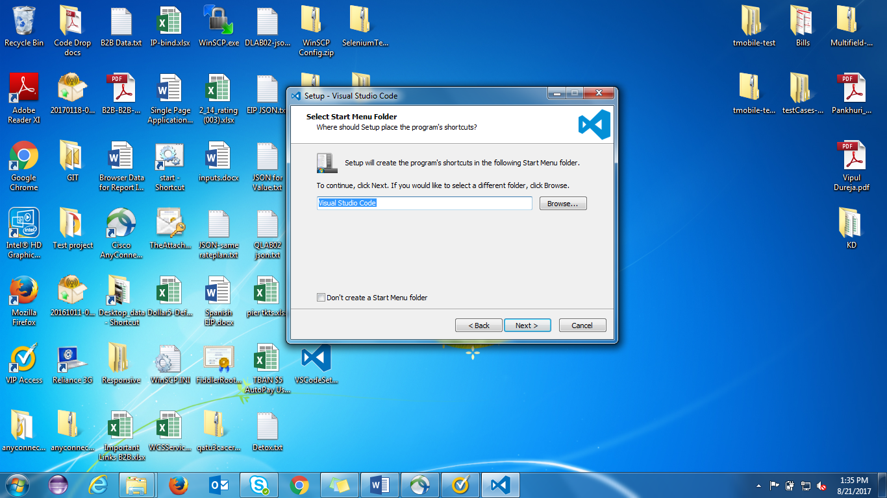

1. click on **Next**

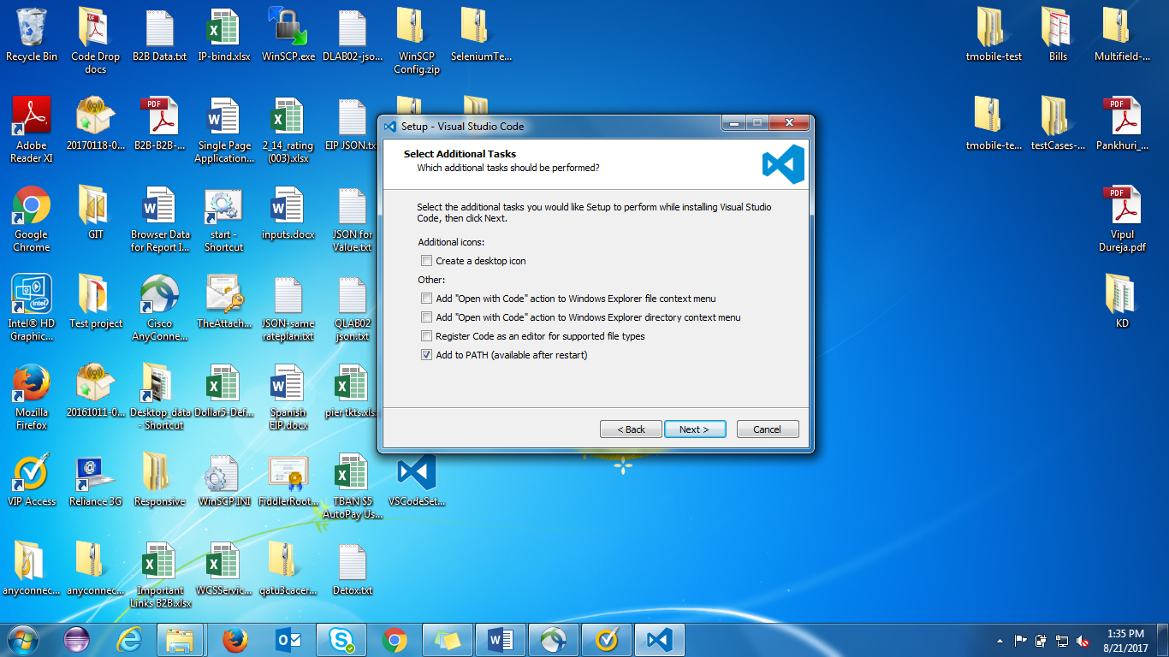

1. Just **click** on the last option for **path variable**, rest option is depending on your requirement (Optional)

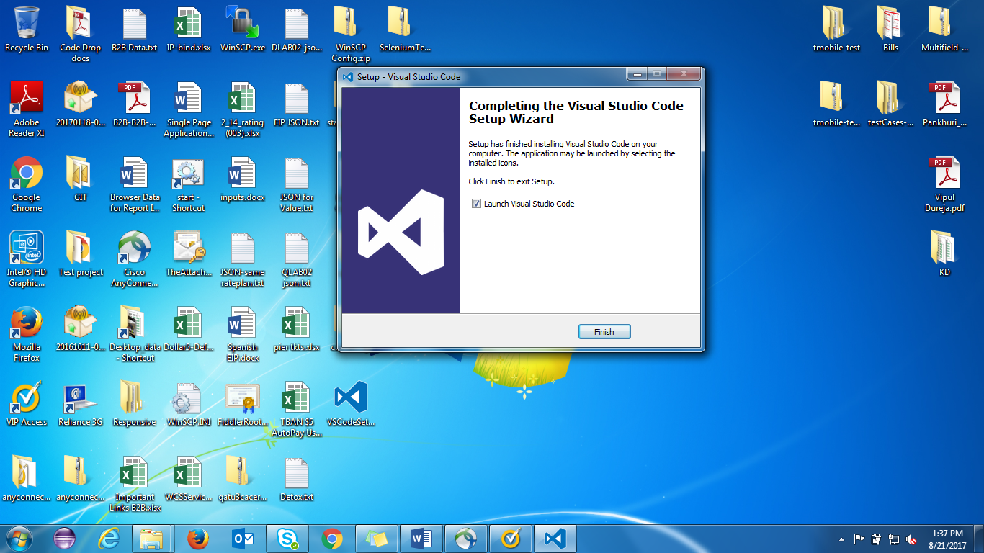

1. ***Congrats!*** You have the smart editor for start angular, so let’s do some basic configuration to make editor smarter.

#### Editor Basic Configuration

1. Auto save

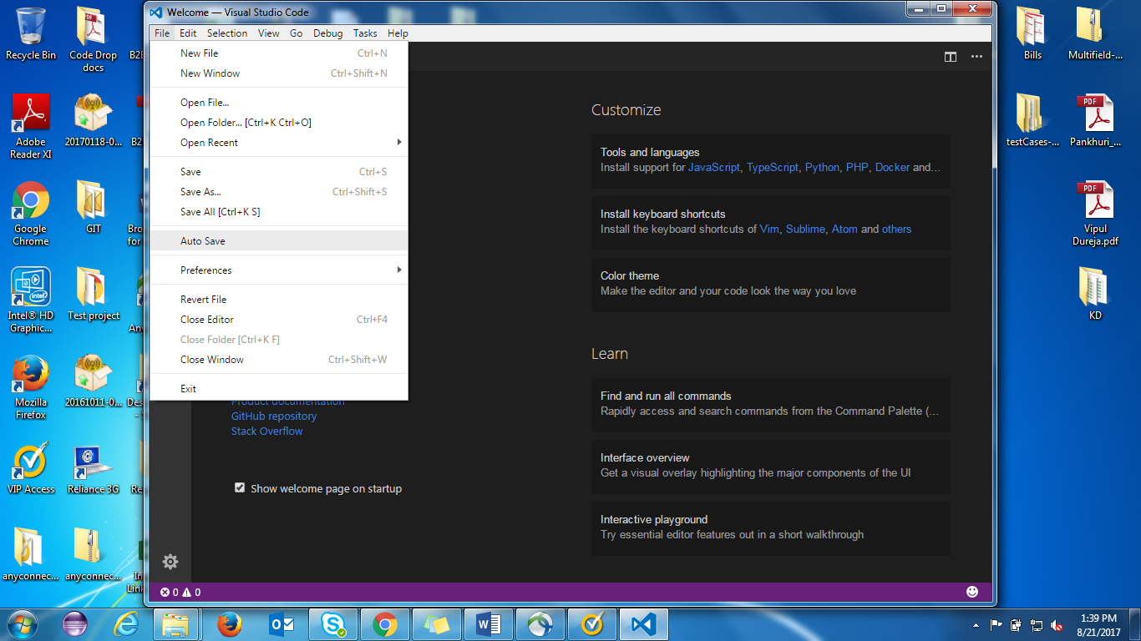

Click on **File** from the menu then click on **Auto Save** (This will save your written code automatically you don’t need to save it manually)

1. **Integrated Terminal**

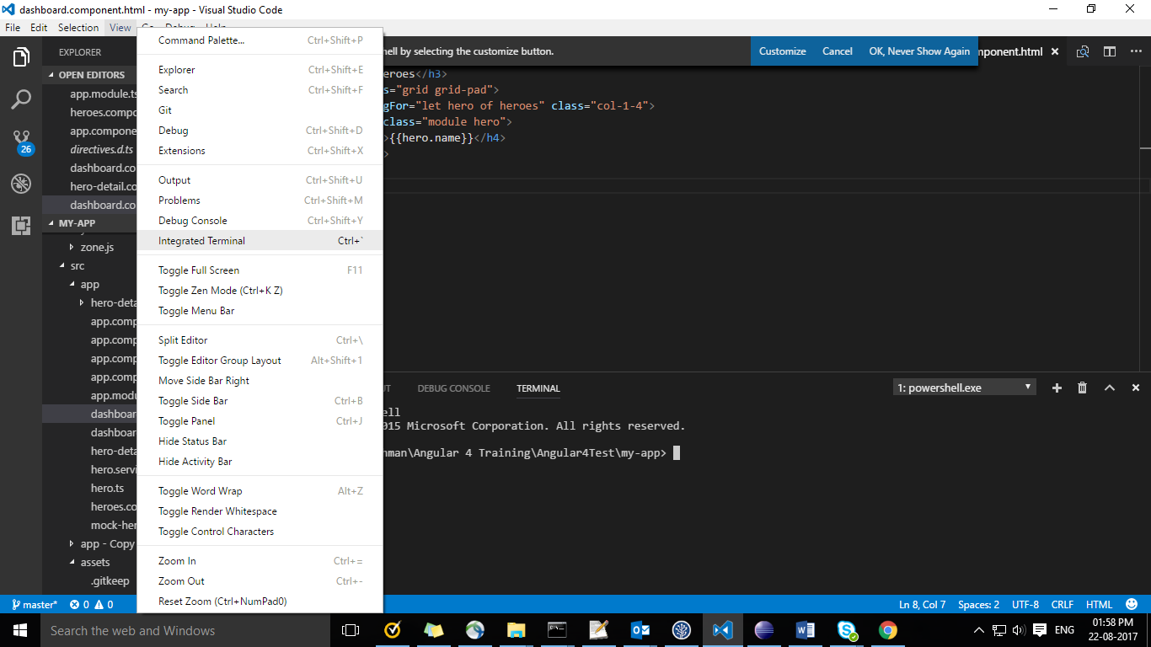

Click on **View** from menu than click on **Integrated Terminal**

**Note:** This will help you to **run command from Visual code studio directly** – You don’t need to open command window seperatly

## Setup Node Environment (Node NPM)

* Skip this step if you have already node in your system

### Install Node and NPM

Go to the : <https://nodejs.org/en/>

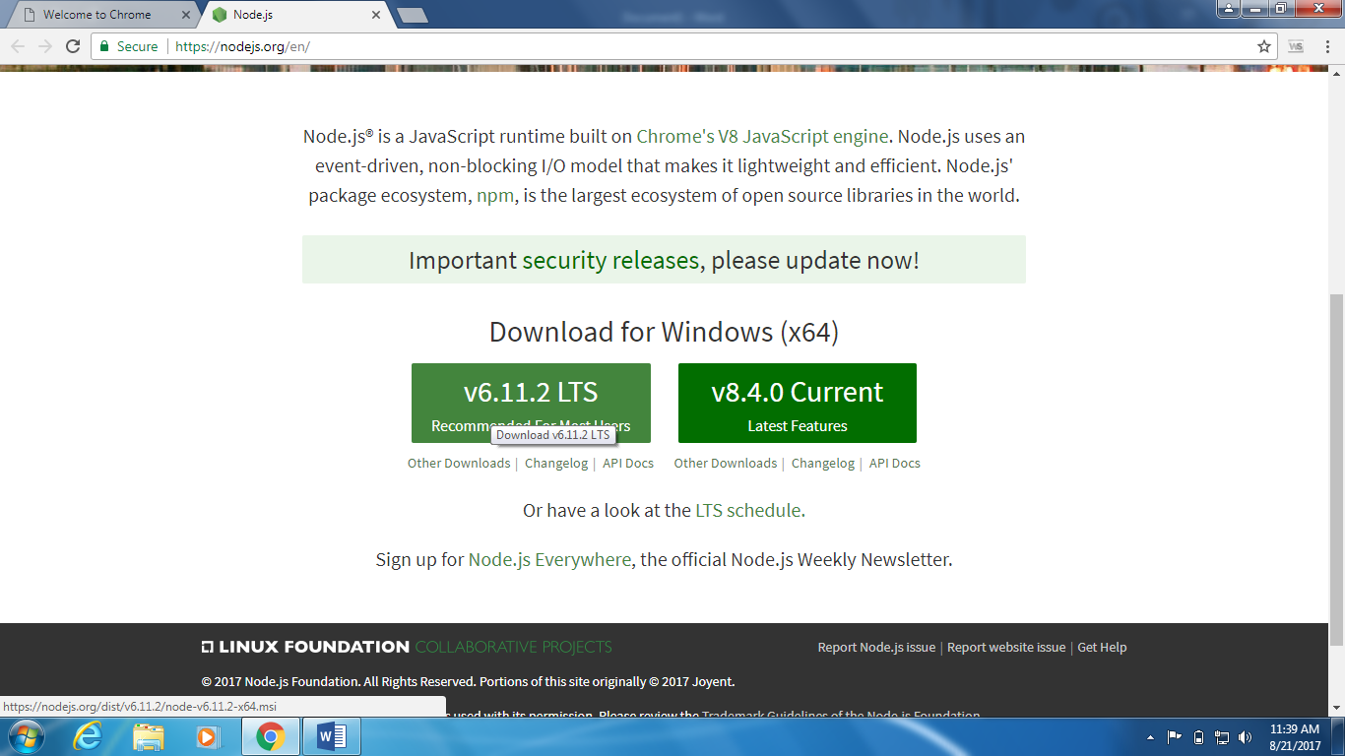

Download the recommended one, here is **v6.11.2.LTS**

Double click on the setup

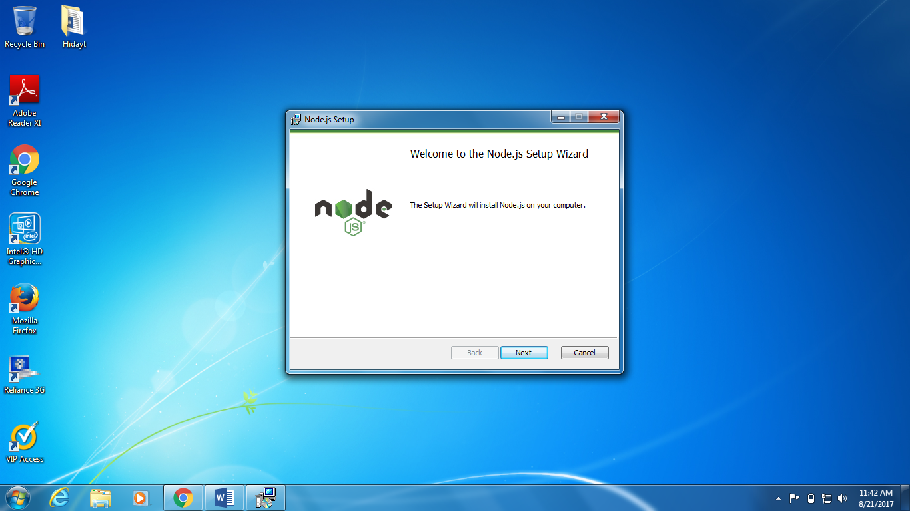

Click **Next**

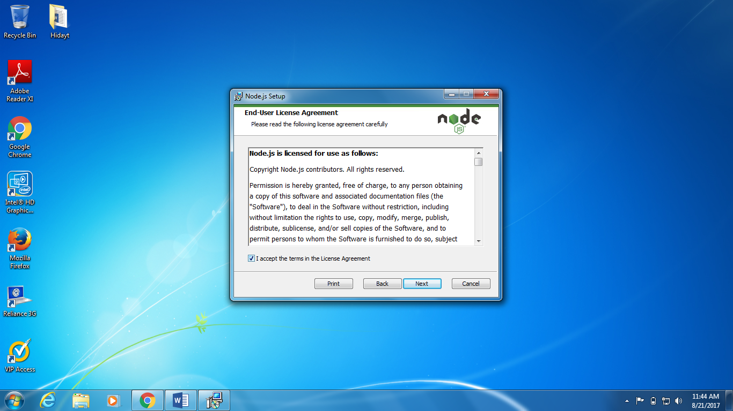

Accept license agreement then **Next**

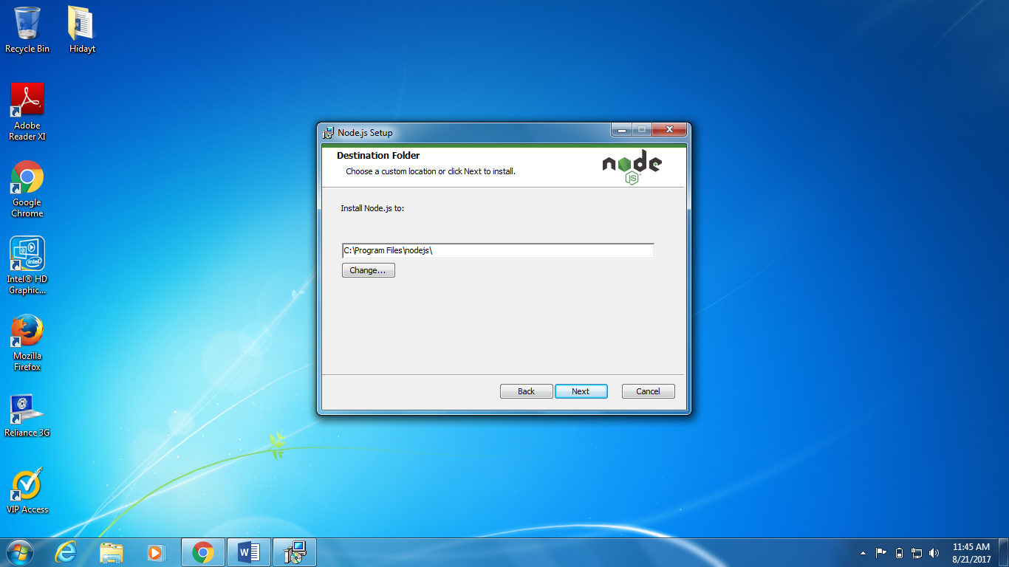

Select path to install – **Suggestion**: Keep it default

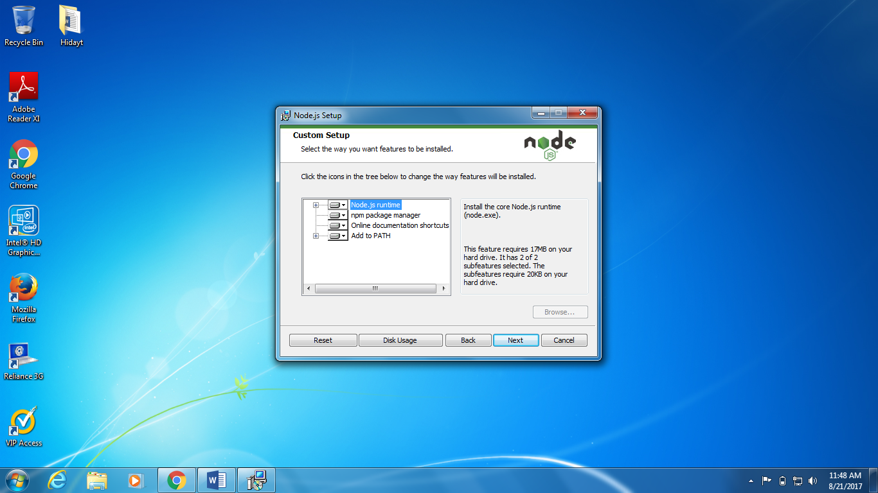

Click on **Next**

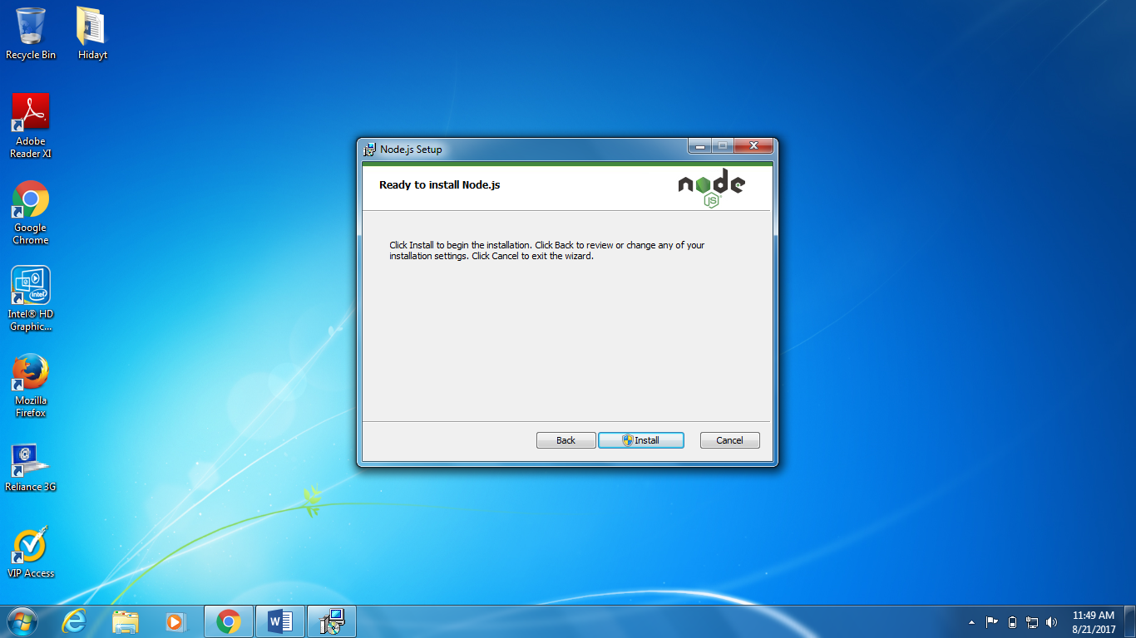

Click on Install – After installation, open command window using Ctrl+R then type cmd and hit enter.

Then verify the **Node** and **NPM** using below commands:

**node -v**

**npm -v**

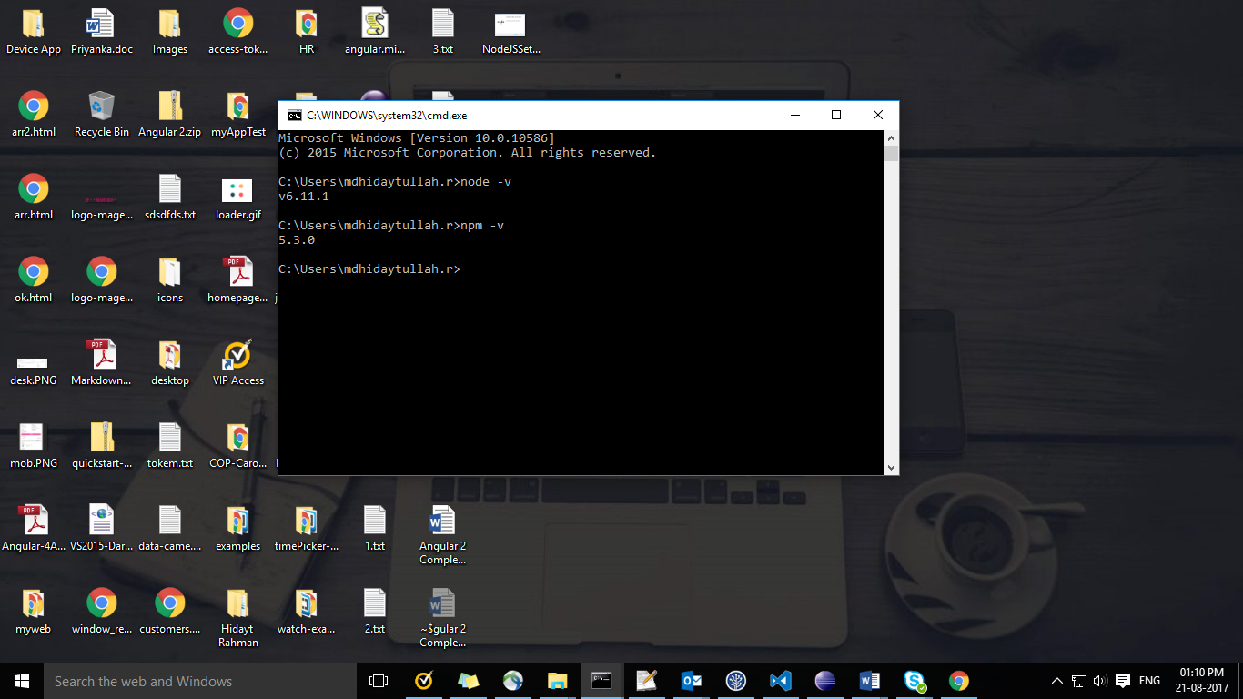

**Note: Node** version should greater than **v6.9** and **NPM** should be greater than **3.0** for run Angular 4

In sort: Angular 4 support latest version of node

(Currently we’ve Node **v6** and npm **v5)**

# Start with Angular 4



Now you’re ready to play with angular 4

## First Project Setup

### Basic requirement for angular 4

You should have an understanding of following technologies:

1. HTML CSS – Basic Knowledge
2. JavaScript – (Object, Array, functions, statements etc.)
3. TypeScript
4. OOPS concepts
5. ES6 – (class, extend, arrow function, import)
6. MVC application – Basic Idea

“ If you have above skills you are made for angular 4 ☺ ”

### Angular CLI

Angular CLI is stands for **Command Line Interface** tools, which will help you to create a project, add files, and more development tasks such as Building, Testing, and deployment.

#### Let’s setup Development Environment

##### Install CLI

**Step 1:**

Install angular CLI globally using command below:

**npm install –g @angular/cli**

**Let me describe each command role:**

**npm install** is a node command to install any packages

**-g** this will install package globally

**@angular/cli** It’s an angular CLI package to start angular development environment

**Note:** Verify angular CLI is installed or not using below commands

**ng -v**

Or

**ng --version**

##### Create a new project

**Step 2:**

Create new folder with this name “**Angular App**” or keep name whatever you want

Then open Command from the same location

In my case it is : *E:\Hidayt Rahman\T-Mobile Angular\Angular App*

Refer. Screen below:

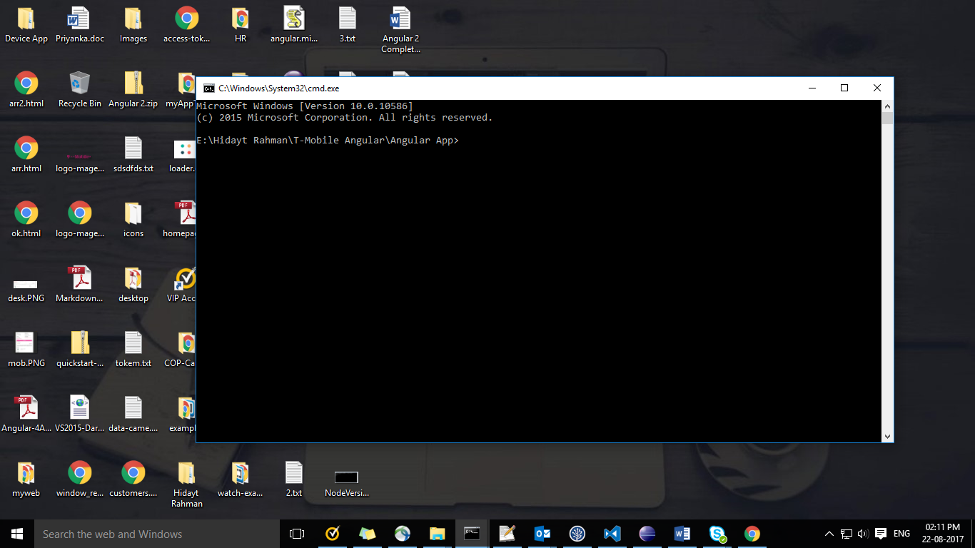

Create new project with **complete structure (Skelton) of angular 4 application** using below command

**ng new my-app**

After this command you will see something like this: (ref. below screen)

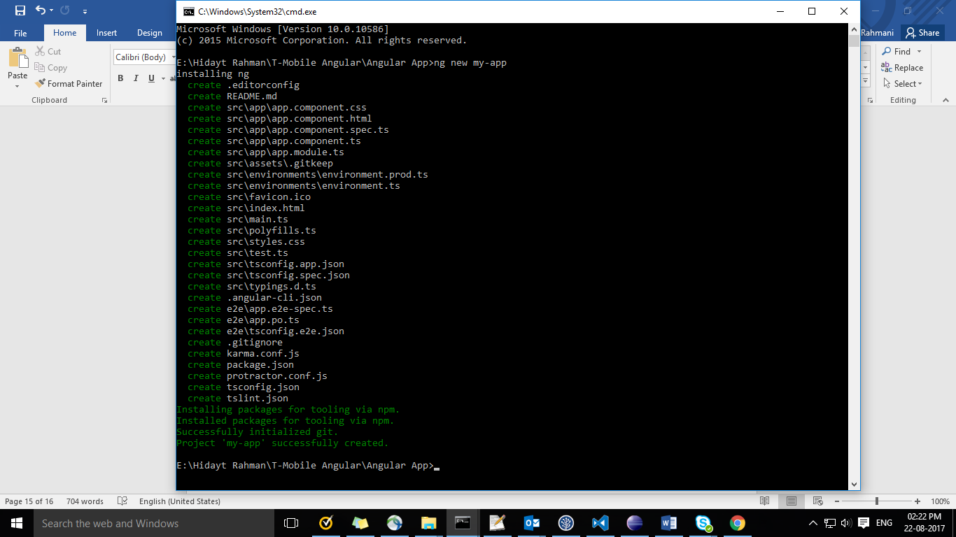

**Patience Required!** Just relax take one cup of tea and enjoy this screen ☺

After finishing this command go to the folder “**Angular App**”, there you will see one new folder with the name “**my-app**”

File Structures below (ref. screen)

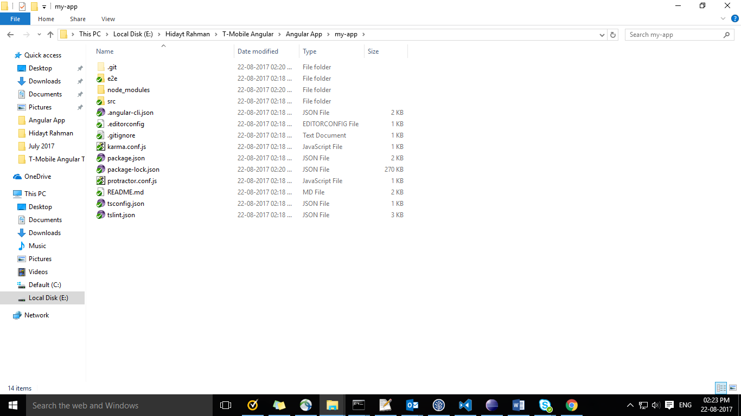

Don’t worry, Explanation is pending for each files, for now we’ve to run the application first.

##### Run the first application

Go to the project directory and launch the Command window.

**Mine directory is:** E:\Hidayt Rahman\T-Mobile Angular\Angular App\my-app

And enter the below commands:

**ng serve --open**

**ng serve** command launch the server, watch your files and rebuild the app when you will do changes to those files.

**--open** this will open your app on browser automatically on this address (http://localhost:4200/)

**-o** it’s work like **--open**

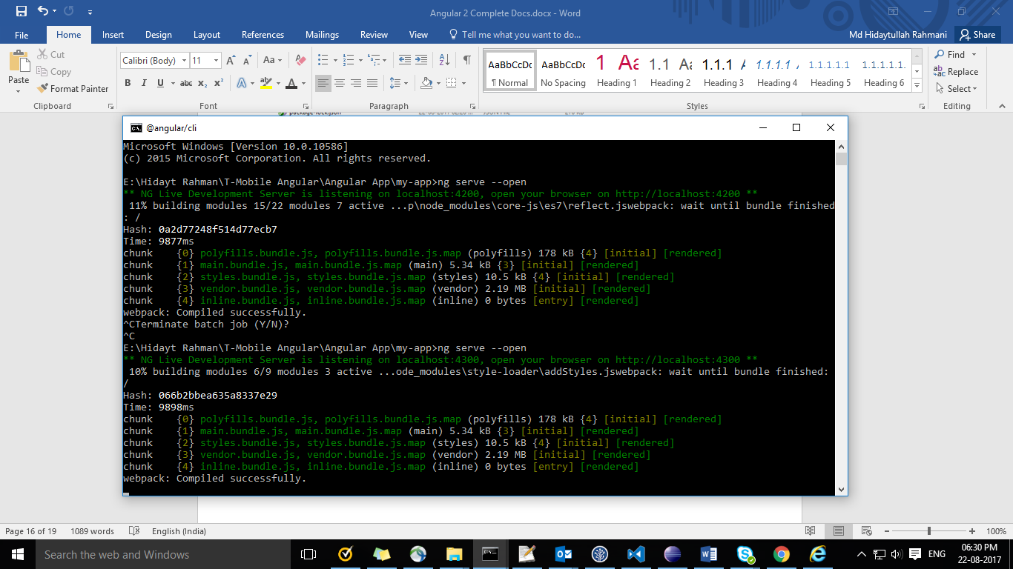

This will launch the server with the current app (ref. screen below)

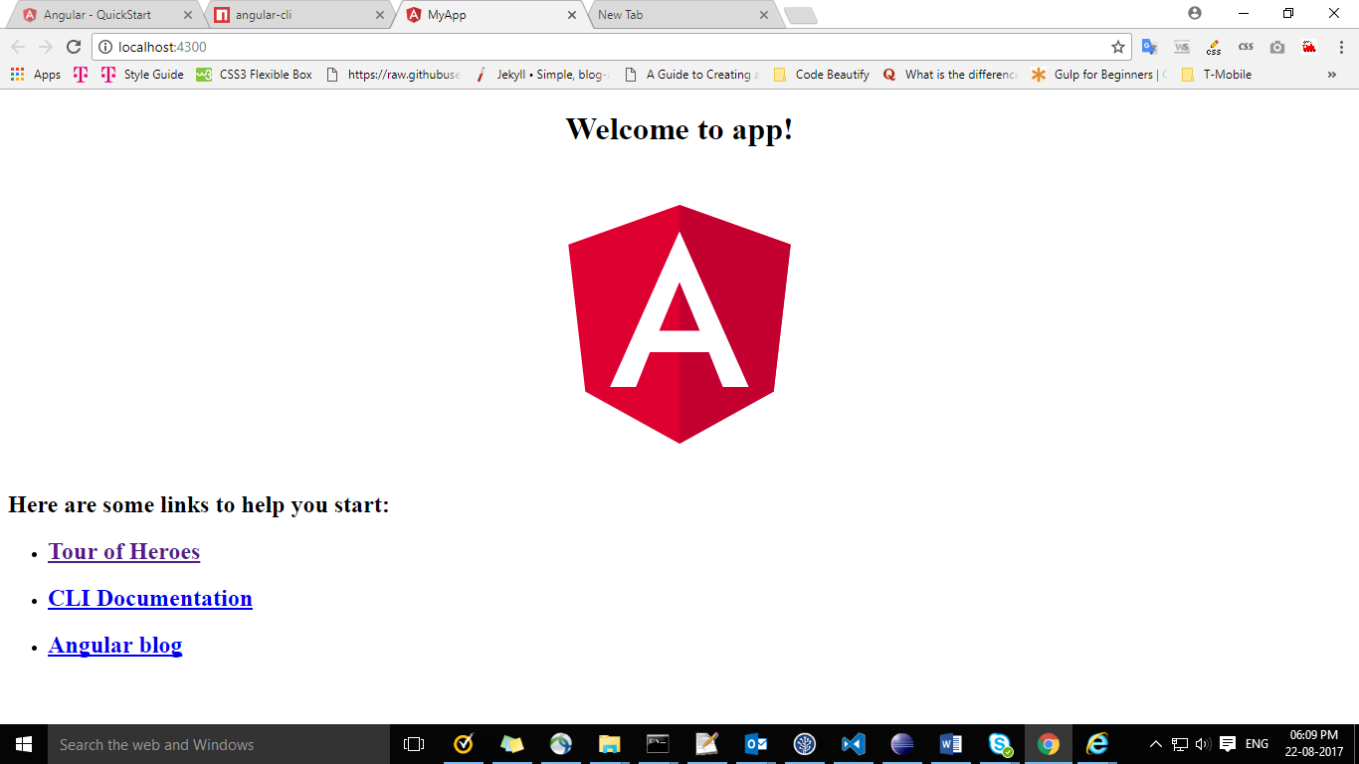You’re done to create first angular4 app, now let’s write ‘**Hello World’** and remove rest content which is showing in above screen.

Let’s open **my-app** folder in **Visual Code Studio** editor using Drag and Draw. Or directly from VS Code editor by clicking **File > Open Folder > Select** “my-app” folder **> Select Folder**

**You will see screen something like this:**

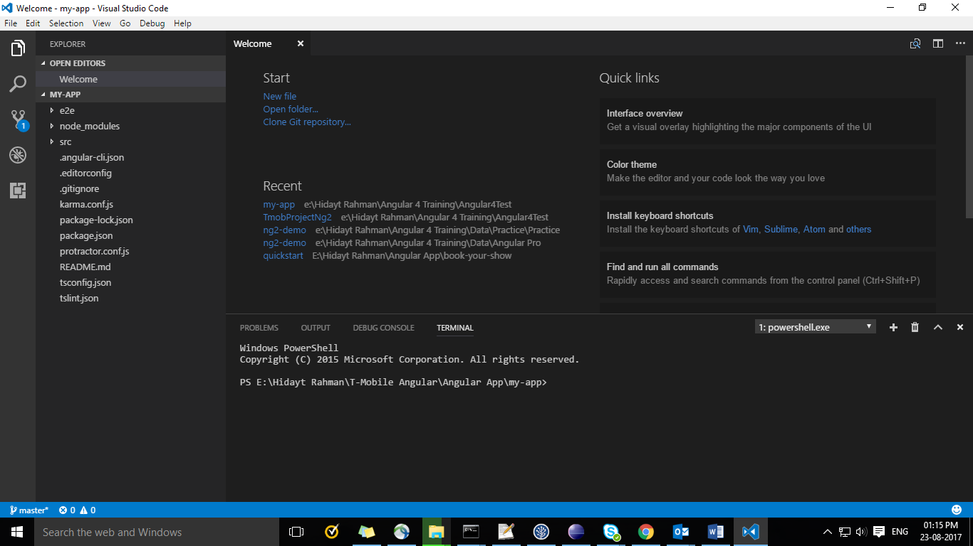

Go to the **src/app** directory

Open **app.component.ts** file

Find Class **AppComponent,** then you will see ‘**title’** variable which is containing **‘app’** value.

Let’s change that to “**World**”

title = 'World';

Now, Let’s go to the **app.component.html** and remove everything

Let’s have our new title, same like below:

<h1>Hello {{title}}</h1>

**Have you noticed** – Expression syntax is quite similar to Angular 1

Output would be something like this:

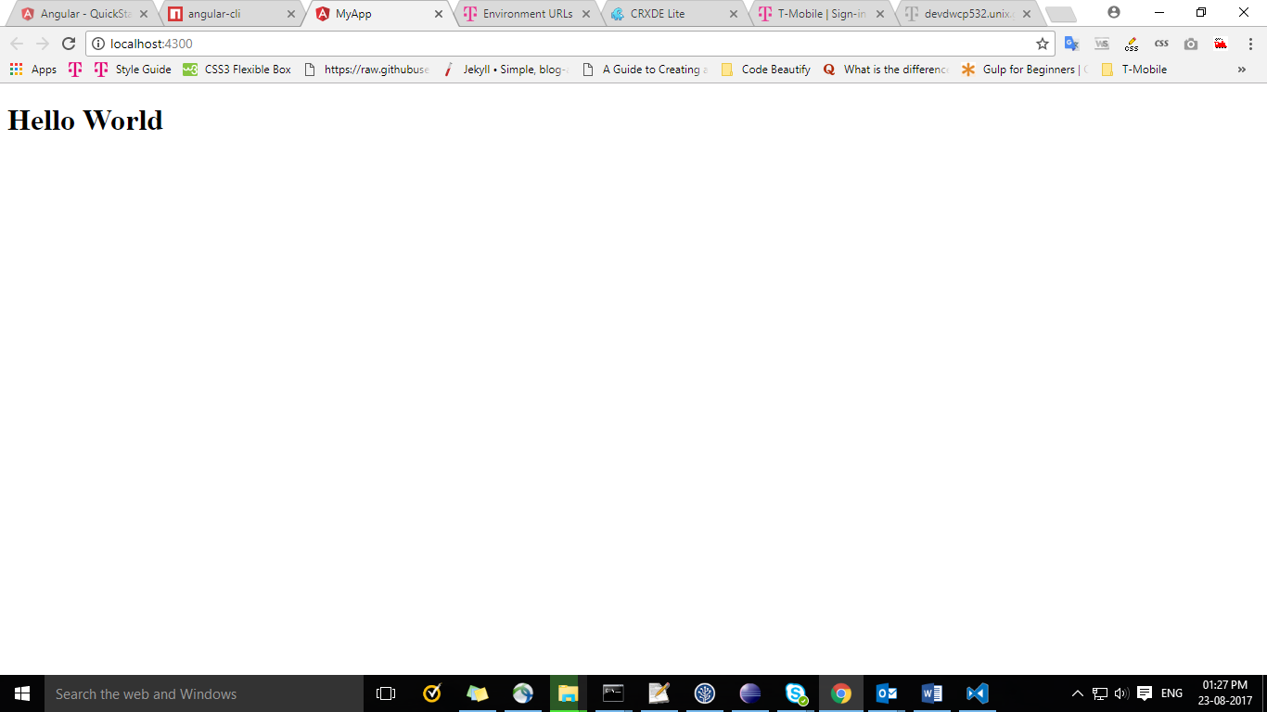

# Advance Setup

## Change default Port

If you have 2 applications and you want to run both apps together then you’ve to change port number.

**Note:** you cannot run 2 applications with the same port number

Change default port by change in **angular-cli.json**

You’ve to add following in **“defaults”** object

"defaults": {

"serve": {

"port": 4500

},

}

# Add SASS / LESS in angular 4

Create a new project with Sass / Less with the following:

ng new my-sassy-app --style=scss

You can also set the --style flag with the following:

* --style=scss
* --style=sass
* --style=less

# F.A.Q about angular 4 Fact

**Why not Angular 3?**

Due to misalignment of router package version. As @angular/router was using v3.3 already, so they switch to Angular 4 Finally.

**Why we use angular 4?**

* The **if else** statement can be easily embedded in HTML components by the enhanced **ngIf** with else tag.
* It supports **Typescript 2.1** and 2.2.
* **Server-side rendering** is also supported.
* Arrival of **ng-template** and deprecation of **template** tag.
* **as** tag, it is useful for let statements, one of the use is as follows *ngFor="let bug of bugs| slice:0:1 as half; index as = i"> {{i+1}}/{{total.length}}: {{bug.count}}

**What’s ECMA and what’s the latest version?**

ECMAScript is a trademarked scripting-language specification. And current version is 6

**What’s the dependency Injection?**

DI is used for modularity and TDD (Test driven development)

**What is Service why we use it?**

Service is used for accessing data from the server. For e.g. **http**

**Http**- Adding search parameters to an **“HTTP request”** has been simplified as,

//Angular 4 -

http.get(`${baseUrl}/api/users`, { params: { sort: 'ascending' } });

//Angular 2-

**const** params = **new** URLSearchParams();

params.append('sort', 'ascending');

http.get(`${baseUrl}/api/users`, { search: **params** });

**Why you use typescript and What’s the advantage of this?**

TypeScript is a client side scripting language which support OOPs concept and it’s used for angular 2/4.

**What is module and why we use it?**

Re-usable code for all components

**What is component and why we use it?**

Component is controller, which contains view + business logic.

**What is CLI?**

CLI is Command Line Interface, this is used to create application structure such as add files, deployment, testing

**What version of ECMA support in angular 4?**

ECMA6

**What is METADATA in angular?**

METADATA is a set of predefined rules to render application.

**What is Router and why we use it?**

Router is used to change page content and URL without page reloaded.

**How to implement Router in angular 4?**

Protractor

**How to build an app write the process?**

ng build

**What type of Unit Testing tools are available in angular 4?**

Such as Karma, Jasmine

**Note**: If am wrong please correct me ☺

Hidayt Rahman